**Jobs finder: A new approach for finding jobs based on web application**

**BY**

**Md. Mokbul Hossain**

**ID: 151-15-469**

**Radwan Ahmed**

**ID: 151-15-503**

**AND**

**Soroardi Hosen Bokhari**

**ID: 151-15-507**

This Report Presented in Partial Fulfillment of the Requirements for the

Degree of Bachelor of Science Computer Science and Engineering

Supervised By

**Md. Mahfujur Rahman**

Lecturer

Department of CSE

Daffodil International University

Co-Supervised By

**Md. Reduanul Haque**

Lecturer

Department of CSE

Daffodil International University



**DAFFODIL INTERNATIONAL UNIVERSITY**

**DHAKA, BANGLADESH**

**DECEMBER 2018**

**APPROVAL**

This Project titled **“**Jobs finder: A new approach for finding jobs based on web application **”**, submitted by Md. Mokbul Hossain ID No: 151-15-469, Radwan Ahmed ID No:151-15-503 and Soroardi Hosen Bokhar ID No:151-15-507 to the Department of Computer Science and Engineering, Daffodil International University, has been accepted as satisfactory for the partial fulfillment of the requirements for the degree of B.Sc. in Computer Science and Engineering and approved as to its style and contents. The presentation has been held on December 8, 2018.

**Board of Examiners**

**Dr. Syed Akhter Hossain Chairman**

**Professor and Head**

Department of Computer Science and Engineering

Faculty of Science & Information Technology

Daffodil International University

**Dr. S M Aminul Haque Internal Examiner**

**Assistant Professor & Associate Head**

Department of Computer Science and Engineering

Faculty of Science & Information Technology

Daffodil International University

**Md. Reduanul Haque Internal Examiner**

**Lecturer**

Department of Computer Science and Engineering

Faculty of Science & Information Technology

Daffodil International University

**Dr. Mohammad Shorif Uddin External Examiner**

**Professor**

Department of Computer Science and Engineering

Jahangirnagar University

# DECLARATION

We hereby declare that, this project has been done by us under the supervision of **Md**. **Mahfujur Rahman, Lecturer, Department of CSE** Daffodil International University. We also declare that neither this project nor any part of this project has been submitted elsewhere for award of any degree or diploma.

**Supervised by**

**Md. Mahfujur Rahman**

Lecturer

Department of CSE

Daffodil International University

**Co-Supervised by:**

**Md. Reduanul Haque**

Lecturer

Department of CSE

Daffodil International University

**Submitted by:**

**Md. Mokbul Hossain**

ID: 151-15-469

Department of CSE

Daffodil International University

**Radwan Ahmed**

ID: 151-15-503

Department of CSE

Daffodil International University

**Soroardi Hosen Bokhari**

ID: 151-15-507

Department of CSE

Daffodil International University

# ACKNOWLEDGEMENT

First we express our heartiest thanks and gratefulness to almighty God for Her divine blessing makes us possible to complete the final year project successfully.

We really grateful and wish our profound our indebtedness to Md. Mahfujur Rahman Lecturer, Department of CSE Daffodil International University, Dhaka. Deep Knowledge & keen interest of our supervisor in the field of “Online Job portal System” to carry out this project. Her endless patience ,scholarly guidance ,continual encouragement , constant and energetic supervision, constructive criticism , valuable advice ,reading many inferior draft and correcting them at all stage have made it possible to complete this project.

#### We would like to express our heartiest gratitude to Dr. S.M. Aminul Haque, Assistant Professor, Department of CSE, for his kind help to finish our project and also to other faculty member and the staff of CSE department of Daffodil International University.

We would like to thank our entire course mate in Daffodil International University who took part in this discuss while completing the course work.

Finally, we must acknowledge with due respect the constant support and patients of our parents.

8 December 2018

# ABSTRACT

In the current state of affairs, there's a competition in each skilled ﬁeld. It is also true for the job market. A job portal is a website dedicated to online information about recruiters as well as job seekers. A job portal helps each the duty seekers and recruiters ﬁnding the correct organization for the workers. In the scenario of the assignment, we are required to develop a web-based online Job Portal System. In this time of recession wherever everybody, is either experienced or fresher, is in search for a job. This job portal will encourage be awfully useful since it allows users of the various profile to transfer their CV, search job on the basis of their qualification. Viewing available jobs, or applying for the duty at the agency may be in serious trouble that jobseekers must move to the agency and check the offered jobs at the agency. Job seekers check the list of jobs offered and apply the duty. Then the agency can show offered jobs for the job seeker for his qualifications and so updates the roles info. The developed Job Portal system is web-based which needs worker Registration & Profiles, Job Search, leader Registration & Profiles, and Subscription choice for each worker and employer etc. The employer will add Own Profile and post jobs and Job Seeker will Search Jobs based on the region (Country, State, and City), Qualification, and Company wise.

**TABLE OF CONTENTS**

**CONTENTS** **PAGE**

Title page i

Approval ii

Declaration iii

Acknowledgement iv

Abstract v

**CHAPTER**

CHAPTER 1: INTRODUCTION 1

1.1 Introduction 1

1.2 Motivation 1

1.3 Objectives 1

1.4 Expected Outcome 1

CHAPTER 2: BACKGROUND 2-3

2.1 Introduction  2

2.2 Related work 2

2.3 Comparative Studies 2

2.4 Scope of the Problem:  3

2.5 Challenges:  3

CHAPTER 3: REQUIREMENT SPECIFICATION 4-22

3.1 Business Process Model:  4

3.2 Requirement Collection and Analysis: 5

3.2.1 Job Seeker Requirment 5

3.2.2 Job Holder Requirment 6

3.2.3 Admin 6

3.2.Technical Requirement:................................................................................... ... . 7

3.2.5 Requirement components.......................................................................................... 8

3.2.5.1 Hardware Requirment.......................................................................... . 8

3.2.5.2SoftwareRequirment.................................................................................................9

3.3 Use Case Modeling............................................................................................ . 9

3.3.1 Use Case Model 10

3.3.2 Use Case Description 11

3.4 Logical Data Model 20

3.5 Design Requirments 21

3.5.1 Job Seeker Requirment 21

3.5.2 Job Holder Requirment 21

3.5.3 Admin Requirment 22

CHAPTER 4: DESIGN SPECIFICATION **22-24**

4.1 Front-end Design: 22

4.1.1 Hypertext Markup Language: 22

4.1.2 Cascading Style Sheet: 23

4.1.3 JavaScript: 23

4.2 Back-end Design: 23

4.2.1 Hypertext Transfer Protocol: 24

4.2.2 Types of HTTP request: 24

CHAPTER 5:IMPLEMENTATION AND TESTING 24-36

5.1 Implementation of Database: 24

5.1.2 Entity Relationship Diagram:  25

5.2 Implementation of Front-end Design: 26

5.2.1 Home Page: 26

5.2.2 Find Candidate 27

5.2.3 Feature job 27-28

5.2.4 Create Cv 28

5.2.5 Job Details Page 29

5.2.6 Skill Test 30

5.2.7 Live Contest 24

5.2.8 view job apply 24

5.2.9 job holden position 24

5.2.10 See Candidate Cv 34

5.2.11 footer 35

5.3 Implementation of interaction 35

5.4 Implementation of Testing 35

5.4.1 Main System Testing 36

5.4.1 Database Testing 36

5.5 Testing result and Report 36

CHAPTER 6: CONCLUSION AND FUTURE SCOPE: 36-37

6.1 Discussion and Conclusion: 36-37

6.2 Scope for Further Developments: 37

**REFERENCES** 38

**LIST OF FIGURES**

**FIGURES PAGE**

Figure 3.1 Business Process Modeling: 4

Figure 3.2 Use Case Models 10

Figure 3.3 Logical Data Model 20

Figure 5.1 E-R diagram 25

Figure 5.2 Home Page View for User ...........................................................................26

Figure 5.3 Find Candidate 27

Figure 5.4 Featured job...................................................... ............... .. 27

Figure 5.5 Create CV ................................................................................ 28

Figure 5.6 Job Details 29

Figure 5.7 skill Test 30

Figure 5.8 Live Contest 31

Figure5.9 View Job 32

Figure5.10 Posting Job 33

Figure5.11 Candidate CV 34

Figure5.12 Footer 35

**LIST OF TABLES**

**TABLE NAME PAGE**

Table 3.1 Hardware Requirement:  8

Table 3.2 Software Requirement: 9

Table 3.3 Use case 1: 11

Table 3.4 Use case 2: 11

Table 3.5 Use case 3: 12

Table 3.6 Use case 4: 12 -13

Table 3.7 Use case 5: 13

Table 3.8 Use case 6: 13-14

Table 3.9 Use case 7: 14

Table 3.10 Use case 8: 15

Table 3.11 Use case 9: 15-16

Table 3.12 Use case10: 16

Table 3.13 Use case11: 16-17

Table 3.14 Use case10: 16

Table 3.15 Use case10: 17-18

Table 3.16 Use case10: 18

Table 3.17 Use case10: 18-19

**Chapter 1: Introduction**

## 1.1 Introduction

This project is developed for an online search Portal for the Placement Details for job seekers. Job-seekers/candidate check the list which jobs are available and apply for the job. Candidate login to upload their information in the form of CV. Then the company/representative check the cv/info then call for job/interview as their requirement.

## 1.2 Motivation

In Bangladesh 4.20 percent people are unemployment, people can’t find their job properly. Newspaper or other Source and this process also time-consuming .So for solving this problem, we want to develop a project like online Job portal System. Here people can find easily their job up to date. [1] This job portal give a platform the job seeker or candidate to easily find job as their qualification & also help company/job holder choose their valuable candidate.

## 1.3 Objectives

* Provide the information of new jobs.
* Reduce time & cost
* Easily find large amount of job.
* Search According their Skill.
* Search According their Location.
* Make standard cv
* Online apply for job
* Messaging system
* Get notification when job new job is post
* Perform skill test also have live contest system
* A Company or Organization post their New Job
* To Provide the information resume and interview tips
* Job holder easily find candidate.

**1.4 Expected Outcome**

We develop this dynamic system with interactive design to find  
appropriate Job for appropriate candidate and also employer will be able  
to post their job and find appropriate candidate for this job. Also communicate with each other via this system [2].

**Chapter 2: Background**

**2.1 Introduction**

Technology has modified the method job seekers seek for jobs and employers realize qualified staff. While employers still advertise job openings through ancient advertising mediums, such as local newspapers and magazines, today employers and job seekers turn to online job portals to find employment matches. Job seekers can advertise their skills and search for available positions, and employers can announce employment openings through job portals such as Jobs Finder. Online job portal may be a web application in-built Laravel. It provide the candidates, ability to register to this application and search for job, manage their jobs. Each candidate have an account with their own home page. [3] The purpose of the application is to provide job portal for job seekers to submit their CV and apply for job, where employer can selected the best candidate from available candidate profile

**2.2 Related work**

In the field of web there is lot of work already have been done. And there are some specialized Systems have been created by some company/job portal. Some honorable mention are bdjobs.com and indeed.com [1]. These portals offer the simplest out there choices so individuals will grab their dream job from completely different sectors within the market.

**2.3 Comparative studies:**

**Purpose:** The purpose of this paper was to compare the leading online job portals Bdjobs.com and indeed.com on the basis of their operational difficulties and features from the perspective of recruitment.

**Design/Methodology/Approach:** The paper presented a descriptive cross-sectional survey of the employees and Job Holder. With the help of an in-depth interview of experts, operational difficulties and features were identified and their performance was compared using independent sample test.

**Originality/Value:** The paper will be of value to those interested in recruitment activities, recruitment consultancy as a business, and online job portals as a business. It is suitable for academics and practitioners alike.

**2.4 Scope of the Problem:**

The canvasser cares with an internet Job Portal, Scopes for the system are as follows: -

* Maintain Job Seeker and Employer records
* To connected Global people

Employers have to be compelled to advertise the vacancies and type all personal details, conduct selection procedures and complete the formalities.

**2.5 Challenges:**

No correct feedback through the portal when leader viewed the profile. Though nowadays many people in the rural area of Bangladesh start to use the internet via mobile phone, In future we want to build it in the mobile application, so that the can also use this service. To reached people and collected their information is our main challenge.

**Chapter 3: Requirement Specification**

**3.1 Business Process Model:**

Business process modeling is the graphical representation of a company’s [business processes](https://tallyfy.com/business-process) or [workflows](https://tallyfy.com/what-is-a-workflow/), as a means of identifying potential improvements. This is usually done through different graphing methods, such as the flowchart, data-flow diagram, etc.

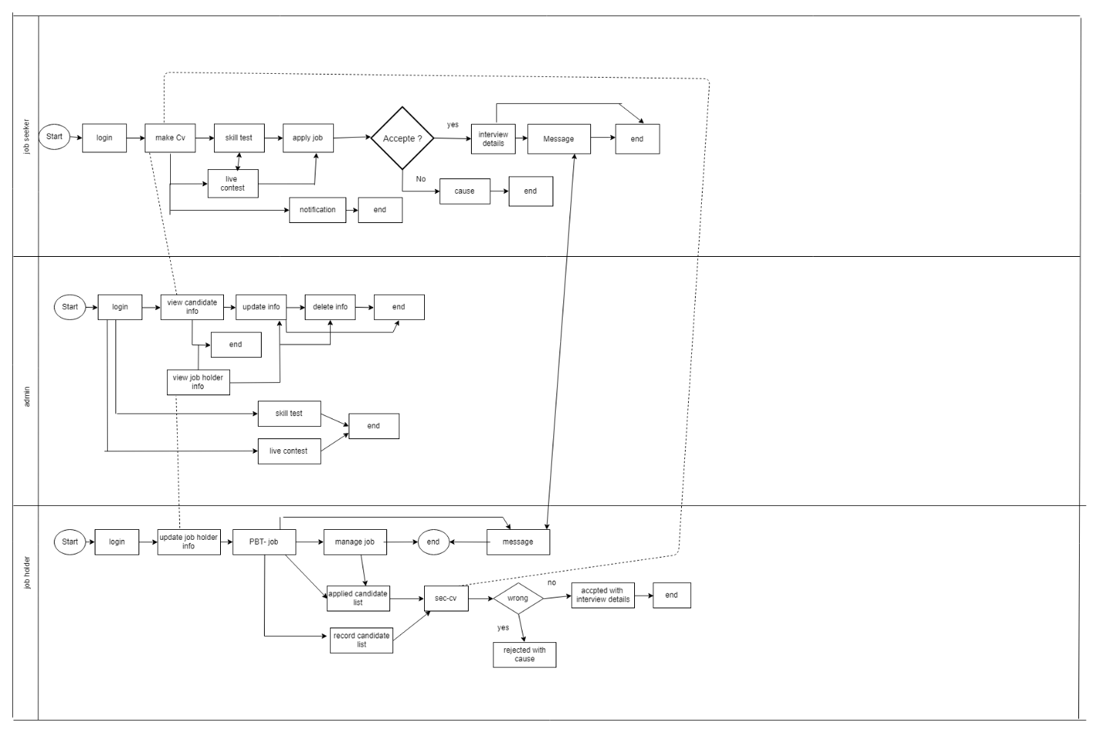

**Figure 3.1: Business Process Modeling.**

## 3.2 Requirement Collection and Analysis:

This is online jobs portal System. This application is created and developed according to the requirement. Requirement of a system classified in two categories: Software and Hardware requirements. We got all the information for this system .We also make sure that this system is compatible with the computer hardware.

### 3.2.1 Job Seeker Requirement:

* Jobseeker if desires to register to the location, a click on Register button can offer him with a registration type. After filling all the small print within the registration type i.e. the mandatory ones which are marked by * has to be filled necessarily and the remaining may be left, the user has to submit it by clicking on submit button. Notification via message will be displayed.
* Only authorized person to access the appliance. When the user logs in to the system, the user must enter login details within the specific username and password fields. The user clicks on the login button and if id and pin number measure valid, then the user is given access to the appliance and user profile is displayed.
* If the user forgets the pin number, it can be retrieved by Option Forgot Password Button. A click on this button can let to a security question and if the solution is verified. The message with the correct pin number is provided to the user.
* After Login job seeker test their skill his related field and jazz himself.
* Job Seeker also attend the contest which arrange by a job holder.
* The job seeker will look for the specified job by getting into keywords, category, work standing, location, qualification, categories, company, location, expertise within the provided fields.
* Jobseeker has the choice to either produce his CV or post his own created CV, it will enable the user to post his created CV on the site.
* As explicit higher than, jobseeker has the option to create his CV or Upload own created CV. If the user clicks on create CV Option, a template is provided to the user in which the user has to fill all his details. After filling all the details and clicking on the submit button, the resume is posted to the site [4].
* A click on Edit CV button helps the task seeker to try and do some amendments within the already created CV and so once more submit it. Delete CV choice can let the jobseeker his extra or created CV from the positioning itself.
* As jobseeker receives daily notifications of jobs that match their keywords via job agent. The user will save jobs that interest them however don't need to use at that individual purpose of your time. A Click on Save Job button can place all the small print of that job within the queue and also the application for it shortly from the list.
* As the job seeker searches for a particular job and Saves Results from it. He has the flexibility to rearrange job search results once all the search results square measure with the user a click on the date or location button permits the user to collect results by date or location.
* See why job holder reject your profile.
* Jobseeker applies the job to a particular company after submitting the resume and the required details. A notification to apply for a particular job according to his requirements is sent to the job seeker. Job Seeker can apply for the job in the same company by clicking on the apply button with the notification.
* Job Seeker additionally has the choice of Report Generation. As the user opts for Report generation a list of how often interested employers viewed the particular jobseeker’s resume is provided to the job seeker.

### 3.2.2 Job holder Requirement:

* Ability to see resume by keywords, job category, days since posted.
* Post jobs with elaborated verbal description (job title, company name, company URL, location, salary, job type, work type, description, required skills...)
* Ability to form and edit a corporation proﬁle.
* Ability to add a Company Logo.
* Retrieve passwords reset by automated email.
* Employer Registration.
* Reporting info on what quantity time left on every job posting and the way long left on CV access
* Payment option by invoice, credit/debit card.
* Information on a variety of vacancy viewings and applications
* Register and sign-up online for Memberships, Job packages, job postings or resume database access.
* Retrieve passwords by automated email.
* Update proﬁle at any time.
* View Submitted Job Seeker CV
* Download CV or application submitted by jobseekers
* Rejected irrelevant CV

### 3.2.3 Admin:

* Manage jobseeker and Admin has the responsibility to manage the leader module jobseeker further because the leader modules. This includes managing their account, usernames and passwords etc.
* Send Notification messages to whenever associate user subscribes to the location as a leader and jobseeker leader or jobseeker, the admin can have to be compelled to send them notification messages confirming their subscription.
* Administrator provides usernames and authentication to user’s passwords to the users and also the admin has the duty to make user of the website as an employer or jobseeker depending on the type of registration made by the user.
* Manage Payments of each leader and Job Seekers.
* Add New Services, associated with Employers or Job Seekers.
* Send Message to leader and Jobseeker for Subscription etc.
* Provide Roles and Authentication to Users
* Ability to vary the planning and feel of your website by ever-changing model.
* Most Recent Jobs to be displayed on home page.
* Search jobs supported keywords, categories, locations etc.
* Create / Edit / Save as several icon sets as you prefer
* Location management console to add/edit/remove locations that jobs will be denoted.
* Manage premium employers
* Admin can Add/Edit/Delete/Approve/Disapprove any job
* Private labeled and totally integrated along with your existing internet site’s look and feel
* Search Job seekers and Employers on the premise of Keyword, name, Email-address, Country, etc.
* Manage Featured Employers Showcase.
* Setup multiple admins with ﬁle access privileges

### 

### 3.2.4 Technical and Legal Requirement:

The system should be design as to ensure that they continue to work efficiency that the observation with relevant legislation and to check that they are safe guarded from threats such as virus and hackers. The requirement are listed below:

* Data protection facilities and Security data transmission facilities.
* Protection facilities against hacker and cracker and Protection against virus.
* Protection Company or Candidate Data From Hacker

### 3.2.5 Requirement Components:

To carry out project we need hardware and software and those are given below:

#### 3.2.5.1 Hardware Requirement:

To run this project minimum one pc and INTERNET connection need.

|  |  |
| --- | --- |
| Processor | Intel Pentium/AMD processor(500 MHZ) |
| Motherboard | Any |
| Ram | 512 or more |
| Lan | Any |
| AGP Card | Any |
| Sound Card | Any |
| Hard Disk | 60GB |
| Floppy Disk(not mandatory) | 1.44 MB |
| Casing | ATX |
| Monitor | Any Color Monitor |
| Keyboard | Any |
| Mouse | Any |
| CD ROM | 52X |

**Table 3.1 Hardware Requirement.**

#### 3.2.5.2 Software Requirement:

Different Type of software need to developing and maintaining projected website. Details Given below:

|  |  |
| --- | --- |
| **Software** | **Usage** |
| Any version of windows operating system | To start up computer and coordinate all hardware components, application and customized software. |
| Browser | Any kind of web browser which support JavaScript. |

**Table 3.2 Software Requirement**

## 3.3 Use Case Modeling and Description:

Use case diagram is a behavioral [UML diagram type](https://creately.com/blog/diagrams/uml-diagram-types-examples/) and frequently used to analyze various systems. They enable you to visualize the different types of roles in a system and how those roles interact with the system

### 3.3.1 Use Case Model:

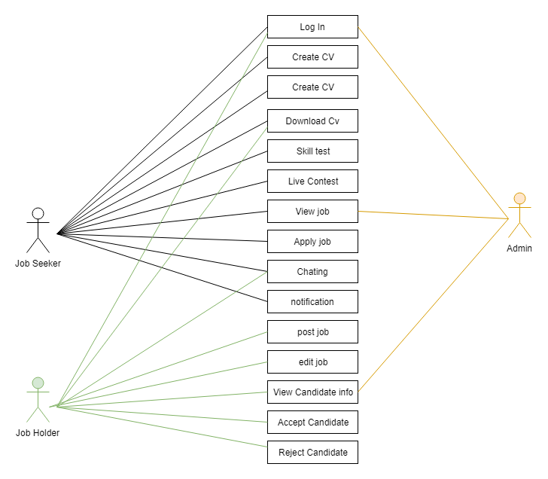

**Figure 3.2 Use Case Model**

### 3.3.2 Use Case Description:

**Table 3.3 Use case 1**

|  |  |
| --- | --- |
| Use Case Id: | 1 |
| Use Case Name: | Log In |
| Created By: | Radwan Ahmed |
| Date Of Creation: | 20-6-2018 |
| Description: | This use case will allow user to log in the system. Job seeker and jobholder can easily enter the system and see whatever want to see. |
| Primary Actor: | Job seeker ,Job holder |
| Secondary Actor: | None |
| Precondition: | None |
| Post condition: | The system will display the Log In page |

**Table 3.4 Use case 2**

|  |  |
| --- | --- |
| Use Case Id: | 2 |
| Use Case Name: | Create cv |
| Created By: | Radwan Ahmed |
| Date Of Creation: | 20-6-2018 |
| Description: | This use case will allow user to Create Cv. Job seeker can easily create their cv and Edit Them. |
| Primary Actor: | Job seeker |
| Secondary Actor: | None |
| Precondition: | None |
| Post condition: | The system will display the CV page |

**Table 3.5 Use case 3**

|  |  |
| --- | --- |
| Use Case Id: | 3 |
| Use Case Name: | Search |
| Created By: | Radwan Ahmed |
| Date Of Creation: | 20-6-2018 |
| Description: | This use case will allow user to search. Job seeker can easily search what he/she want in the system |
| Primary Actor: | Job seeker |
| Secondary Actor: | None |
| Precondition: | None |
| Post condition: | The system will show the search result |

**Table 3.6 Use case 4**

|  |  |
| --- | --- |
| Use Case Id: | 4 |
| Use Case Name: | Download CV |
| Created By: | Radwan Ahmed |
| Date Of Creation: | 20-6-2018 |
| Description: | This use case will allow Job seeker to Download cv and See. |
| Primary Actor: | Job seeker |
| Secondary Actor: | System |
| Precondition: | User have to find valid information |
| Post condition: | The system will store the information |

**Table 3.7 Use case 5**

|  |  |
| --- | --- |
| Use Case Id: | 5 |
| Use Case Name: | Skill test |
| Created By: | Radwan Ahmed |
| Date Of Creation: | 20-6-2018 |
| Description: | This use case will allow Job seeker to test  Their Skill. |
| Primary Actor: | Job seeker |
| Secondary Actor: | System |
| Precondition: | None |
| Post condition: | None |

**Table 3.8 Use case 6**

|  |  |
| --- | --- |
| Use Case Id: | 6 |
| Use Case Name: | Live Contest |
| Created By: | Radwan Ahmed |
| Date Of Creation: | 20-6-2018 |
| Description: | This use case will Job seeker to start to join live contest. |
| Primary Actor: | Job seeker |
| Secondary Actor: | system |
| Precondition: | Job seeker must have good internet Connection To attend the contest. |
| Post condition: | None |

**Table 3.9 Use case 7**

|  |  |
| --- | --- |
| Use Case Id: | 7 |
| Use Case Name: | View job |
| Created By: | Radwan Ahmed |
| Date Of Creation: | 20-6-2018 |
| Description: | This use case will allow Job seeker to view job and apply this. |
| Primary Actor: | Job seeker |
| Secondary Actor: | None |
| Precondition: | Log in |
| Post condition: | The System will display different job Vacancies. |

**Table 3.10 Use case 8**

|  |  |
| --- | --- |
| Use Case Id: | 8 |
| Use Case Name: | Apply job |
| Created By: | Radwan Ahmed |
| Date Of Creation: | 20-6-2018 |
| Description: | This use case allow Job seeker to apply different job. |
| Primary Actor: | Job seeker |
| Secondary Actor: | None |
| Precondition: | Job seeker must need to Log in |
| Post condition: | None |

**Table 3.11 Use case 9**

|  |  |
| --- | --- |
| Use Case Id: | 9 |
| Use Case Name: | Chat |
| Created By: | Radwan Ahmed |
| Date Of Creation: | 20-6-2018 |
| Description: | This use case will Job seeker to start chat |
| Primary Actor: | Job seeker |
| Secondary Actor: | None |
| Precondition: | User must have good internet Connection |
| Post condition: | The System will help to chat job holder and admin. |

**Table 3.12 Use case 10**

|  |  |
| --- | --- |
| Use Case Id: | 10 |
| Use Case Name: | Notification |
| Created By: | Radwan Ahmed |
| Date Of Creation: | 20-6-2018 |
| Description: | This use case Job seeker notify by job holder when post new job. |
| Primary Actor: | Job seeker |
| Secondary Actor: | None |
| Precondition: | User must have good internet Connection |
| Post condition: | None |

**Table 3.13 Use case 11**

|  |  |
| --- | --- |
| Use Case Id: | 11 |
| Use Case Name: | Post job |
| Created By: | Radwan Ahmed |
| Date Of Creation: | 20-6-2018 |
| Description: | This use case will allow user to apply new  Job post. |
| Primary Actor: | Job holder |
| Secondary Actor: | None |
| Precondition: | User must have Log In |
| Post condition: | None |

**Table 3.14 Use case 12**

|  |  |
| --- | --- |
| Use Case Id: | 12 |
| Use Case Name: | Edit job |
| Created By: | Radwan Ahmed |
| Date Of Creation: | 20-6-2018 |
| Description: | This use case will allow Job Holder to Edit  Job post. |
| Primary Actor: | Job holder |
| Secondary Actor: | None |
| Precondition: | Job holder must have Log In |
| Post condition: | None |

**Table 3.15 Use case 13**

|  |  |
| --- | --- |
| Use Case Id: | 13 |
| Use Case Name: | View Candidate info |
| Created By: | Radwan Ahmed |
| Date Of Creation: | 20-6-2018 |
| Description: | This use case will allow job holder to see candidate Information. |
| Primary Actor: | Job holder |
| Secondary Actor: | None |
| Precondition: | Job holder must have Log In |
| Post condition: | None |

**Table 3.16 Use case 14**

|  |  |
| --- | --- |
| Use Case Id: | 14 |
| Use Case Name: | Accept Candidate |
| Created By: | Radwan Ahmed |
| Date Of Creation: | 20-6-2018 |
| Description: | This use case will allow job holder to see accept the request job seeker Information. |
| Primary Actor: | Job holder |
| Secondary Actor: | None |
| Precondition: | Job holder must have Log In |
| Post condition: | None |

**Table 3.17 Use case 15**

|  |  |
| --- | --- |
| Use Case Id: | 15 |
| Use Case Name: | Reject Candidate |
| Created By: | Radwan Ahmed |
| Date Of Creation: | 20-6-2018 |
| Description: | This use case will allow job holder to see Reject the request job seeker Information. |
| Primary Actor: | Job holder |
| Secondary Actor: | None |
| Precondition: | Job holder must have Log In |
| Post condition: | None |

# 3.4: Logical Data Model:

# 

**Figure 3.3 Logical Data Model**

**3.5: Design Requirements:**

**3.5.1: Job Seeker Requirements:**

* Create, View, edit ,download CV
* Make CV as confidential
* Advanced search for jobs
* Search jobs supported keywords, categories, location.
* Apply for jobs on-line in real time
* View Company profiles
* Keep track of the roles that you simply applied
* Define mail alerts for jobs
* Profile management

**3.5.2: Job holder Requirements:**

* Maintain multiple company profiles
* Post multiple job offers
* Edit / deduct job offers
* Make your job offers featured
* Other paid choices like making offers daring, highlight etc.
* Keep track of the applications received
* Remove applications
* Activate the search resume facility by paying fee-based on your wants

**3.5.3: Admin Requirements:**

In this module Admin will add all the qualifications, skill, experience, city, state,

Country and update and delete knowledge regarding the duty provider or job seeker he Can also search for the duty seeker and he can send mail to provide the duty to jobseeker and he may additionally see the roles add by the duty provider.

# Chapter 4: Design Specification

**4.1 Front-end Design:**

For finishing front-end improvement, we've utilized three primary languages in my project.

* HTML
* CSS
* Bootstrap structures
* JavaScript programming
* libraries like JQuery,Vue JS

**4.1.1 Hypertext Markup Language:**

HTML elements unit of measurement the building blocks of Web pages. With markup language constructs, pictures and alternative objects like interactive forms are also embedded into the rendered page. HTML provides a way to form structured documents by denoting structural linguistics for text like headings, paragraphs, lists, links, quotes and alternative things. HTML components square measure diagrammatical by tags, written exploitation angle brackets. Tags such as <img /> and <input /> directly introduce content into the page. Other tags such as <p> surround and provide information about document text and may include other tags as sub-elements. Browsers do not display the HTML tags, but use them to interpret the content of the page [5].

**4.1.2 Cascading Style Sheet:**

It is a decent practice to isolate page structure from its plan. To do as such, CSS is utilized as a styling dialect. It characterizes format, shading, estimate and different traits of page components. CSS report is a content record containing an arrangement of CSS rules, where rule comprises of selector and presentation square. Each standard influences page content indicated in selector guiding either toward: All components of one kind in a DOM, e.g. all <li> labels [10].

* Elements of an equivalent class or id (both are label traits). In CSS, these standards begin with a spot (.) and hash (#) for classes and ids, separately, e.g. ".list" and "#examplebtn".

### 4.1.3 JavaScript:

JS is interpreted programming language generally used at client side to control user input, control browser actions, load additional content to a browser and make changes to the DOM. In short, it gives functionality to a page [10]. JS code can be added to HTML document in two ways

* Inline JavaScript, JS code is written as content of HTML document between opening and closing<Script> tag.
* External JavaScript, JS code is written in external file and reference to the file is defined in <script> tag attribute. Any content enclosed by the <script> tag is not executed [6].

When HTML <script> element is reached, during parsing of HTML document, the JS code defined by the tag is immediately executed in a browser using built-in JS interpreter.

## 4.2 Back-end Design:

To find, save, or change data and serve it back to the user in front-end code, we've used

* Server-side languages- Laravel
* Tools like MySQL Server

### 4.2.1 Hypertext Transfer Protocol:

HTTP is a protocol describing how browsers and servers communicate with each other over the Internet in order to exchange data. The process works as follows:

* Establishment of a connection between client and WA server.
* If the connection is successful request is sent by the client. It is a message requesting data from a WA server. The data can be of various types - web pages, images, client-side scripts, confirmation of user authentication and more [10].
* The server then sends response which contains requested data together with a status code. There are several types of status codes depending on success or failure of the requested operations.
* Last step closes the connection by either both parties. Both, request and response, are text based messages, each message has three parts :

1. an initial line, defines mainly source of information,
2. Header, zero or more lines specifying additional parameters of the request. III. An optional message body contains data sent by client/server.

### 4.2.2 Types of HTTP request:

When user accesses the WA for the first time, browser sends an unconditional HTTP requests to a server. Server sends back the requested data and the browser may cache the data for later use, if the response’s header allows it [10].

**Chapter 5: Implementation and Testing**

## 5.1 Implementation of Database:

The database implementation or deployment is the process of installation of database software, configuration and customization, running, testing, integrating with applications, and training the users [11]. Its different stages and processes are:

# 5.1.2 Entity Relationship Diagram:

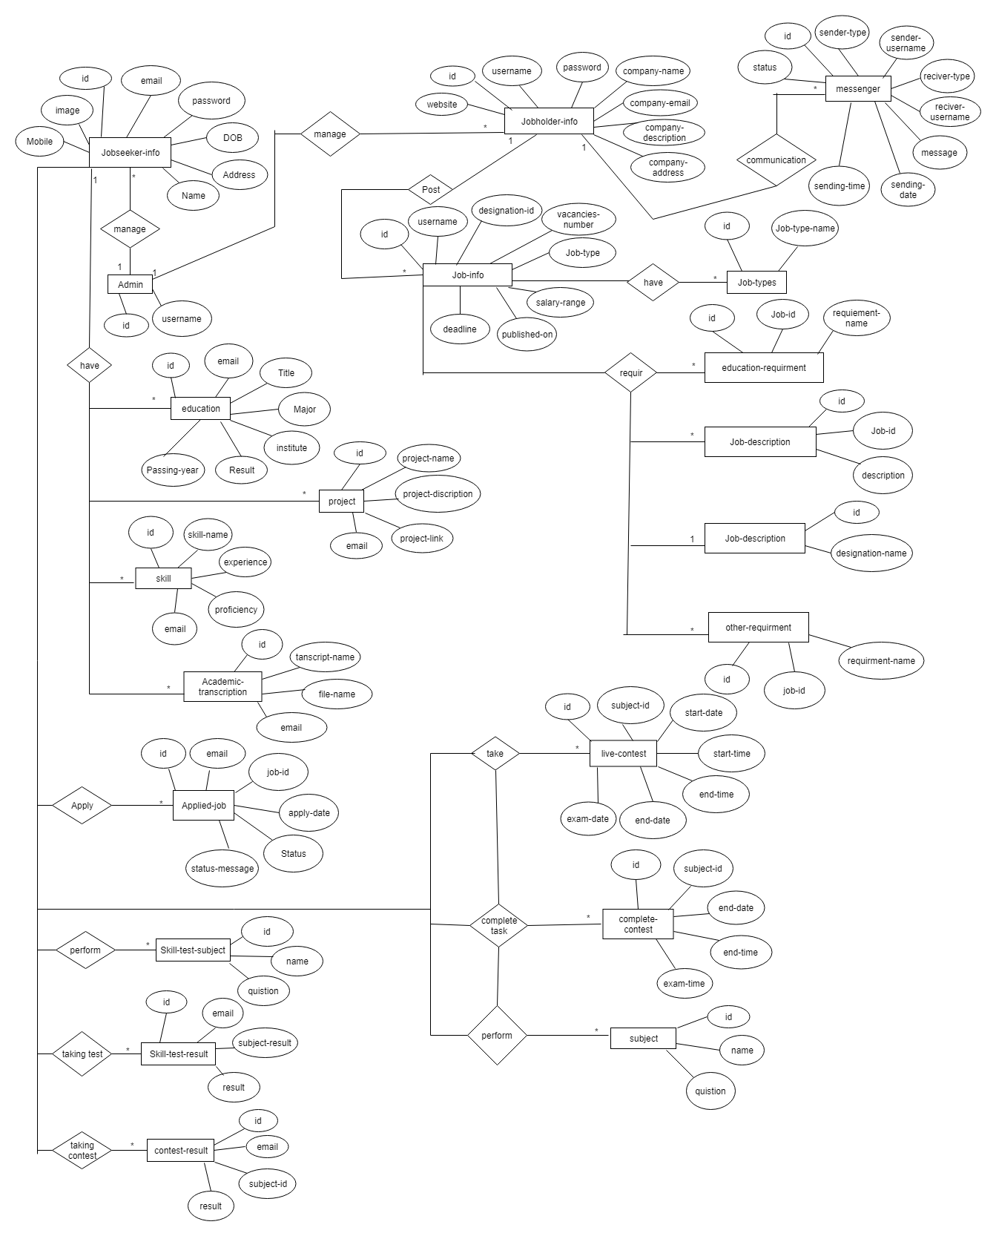

Figure 5.1 Database Design

**5.2 Implementation of Front-end Design:**

Improvement of the customer side of WA is called front-end advancement and front-end (FE) itself is then comprehended as each substance client can see and can connect within a program. It is typically a blend of Hypertext Markup Language (HTML), Cascading Style Sheet (CSS) and JavaScript (JS). Every one of these dialects is deciphered and controlled by an internet browser bringing about a website page - interface client can cooperate with. Set of all accessible pages is called site [7].

### Home Page:

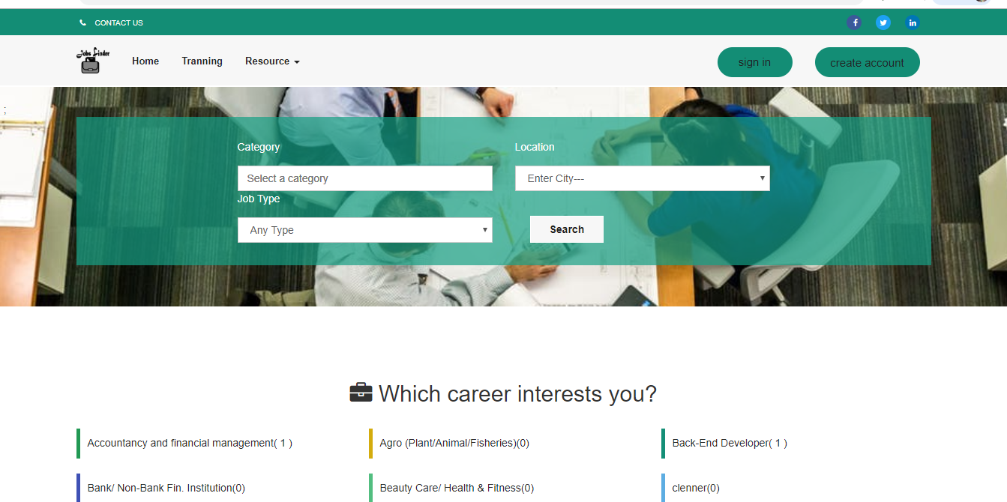

Figure 5.2 Home Page View for all User

**Output:** This is a home page for all user to search job by Location, category & type. You can also access it directly from any part of the website.

### Find Candidate

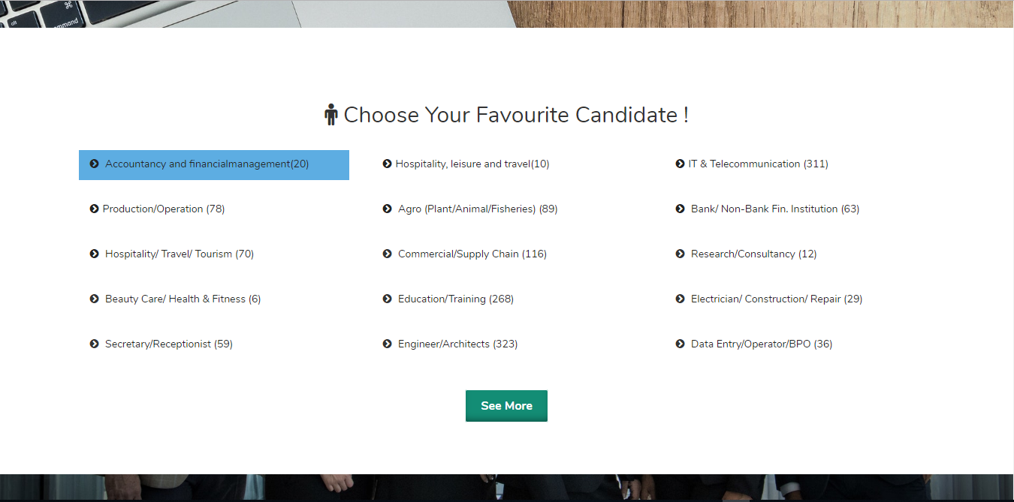

Figure 5.3 Candidate Page for User

**Output:** Here job holder find his candidate as job category.

### Featured job

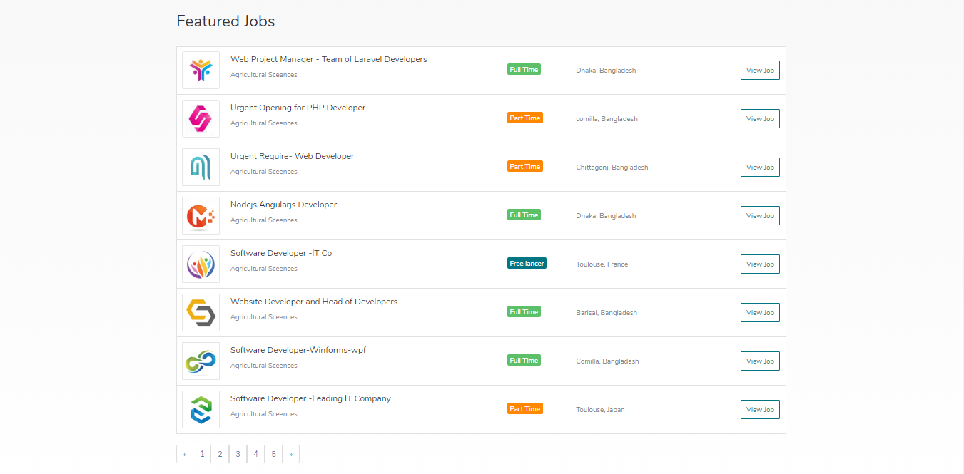

Figure 5.4 Featured job for jobholder

**Output:** User View all popular job which salary more than 30000 in this list and they will able to apply after login.

### Create CV

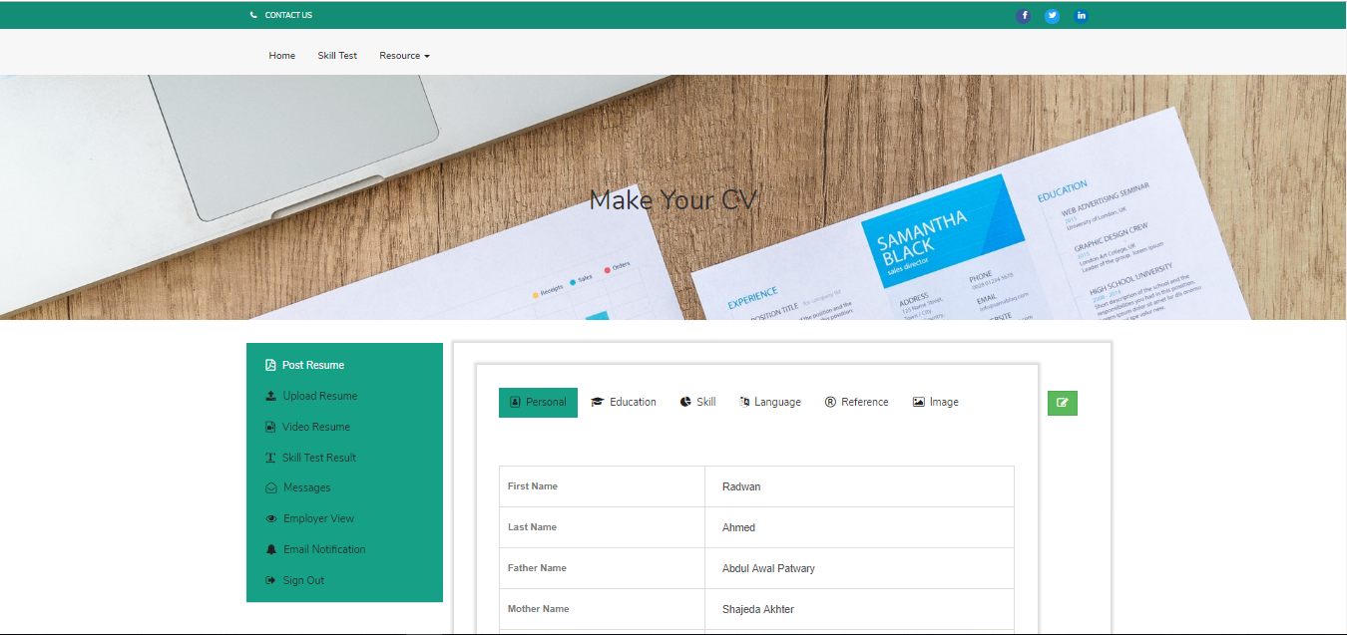

Figure 5.5 create CV

**Output:** Job seeker create their CV after login for job.

### Job details page

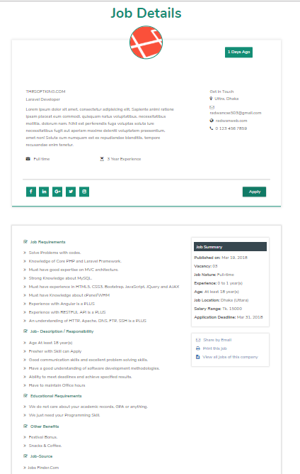

Figure 5.6 job details

**Output:** Here candidate see details the posting jab can apply.

### Skill Test

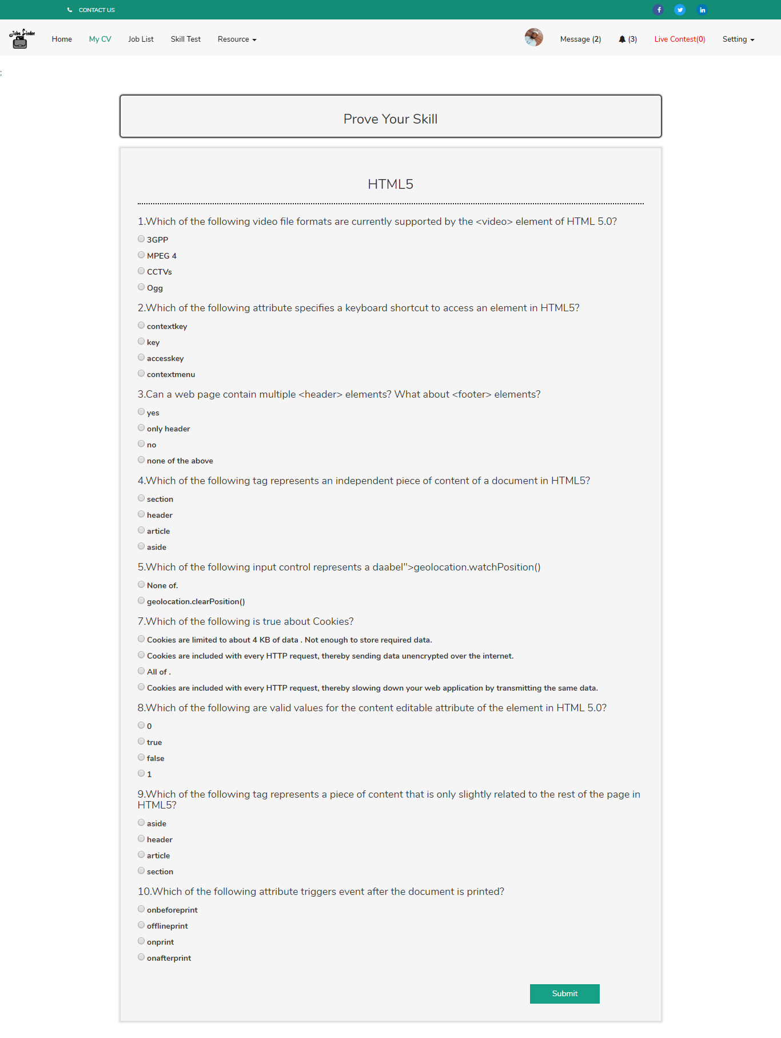

Figure 5.7 skill test

**Output:** Candidate can justify his/her skill

### Live Contest

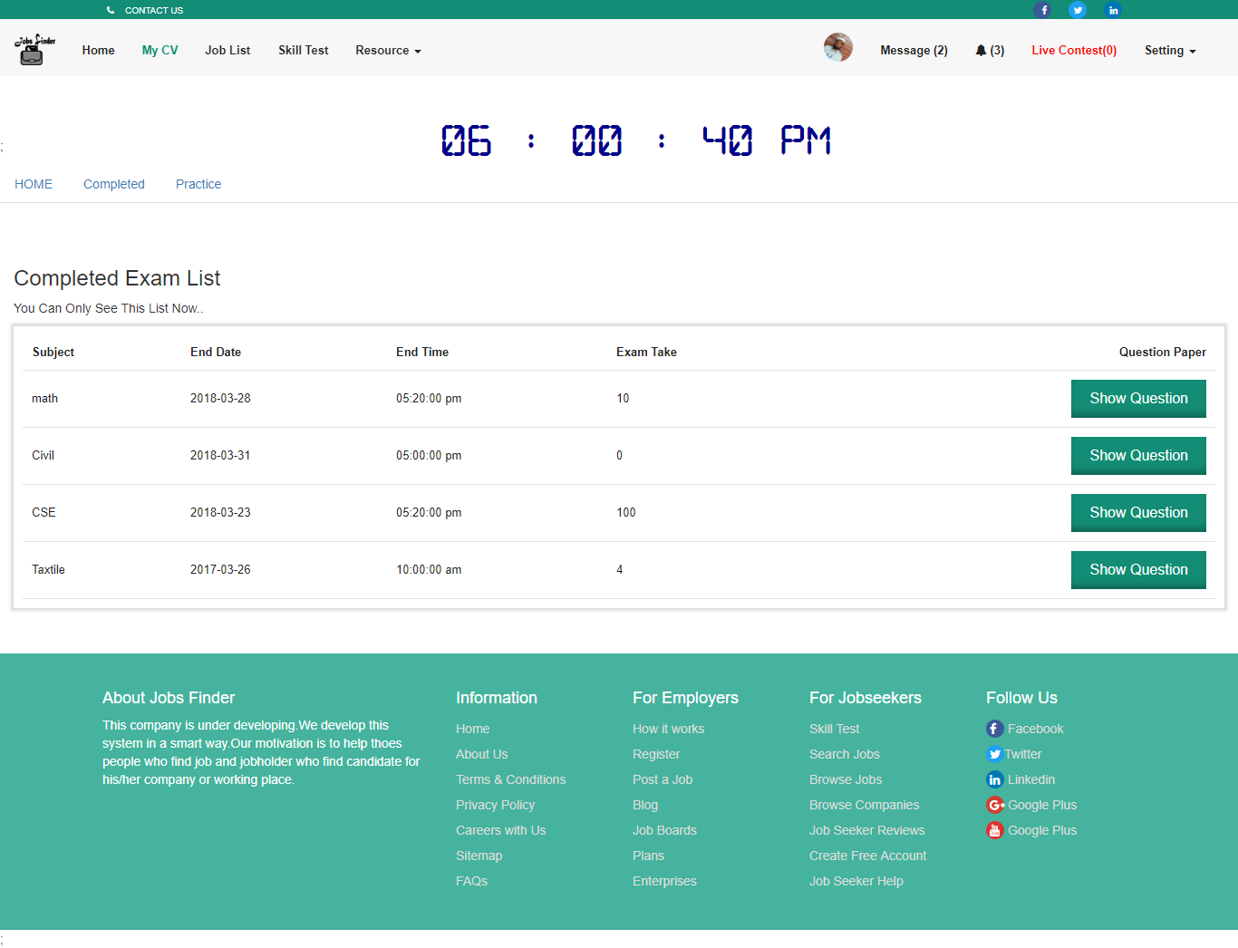

Figure 5.8 live contest

**Output:** Candidate can justify his/her skill by attending live contest.

### View Job and apply

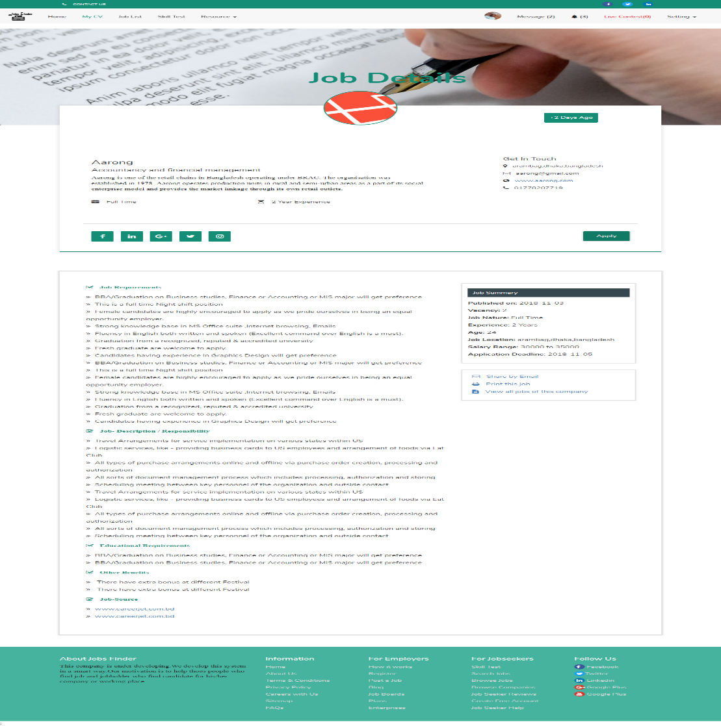

Figure 5.9 view job and apply

**Output:** Candidate can view job and also apply in online.

### Jobholder Posting Job

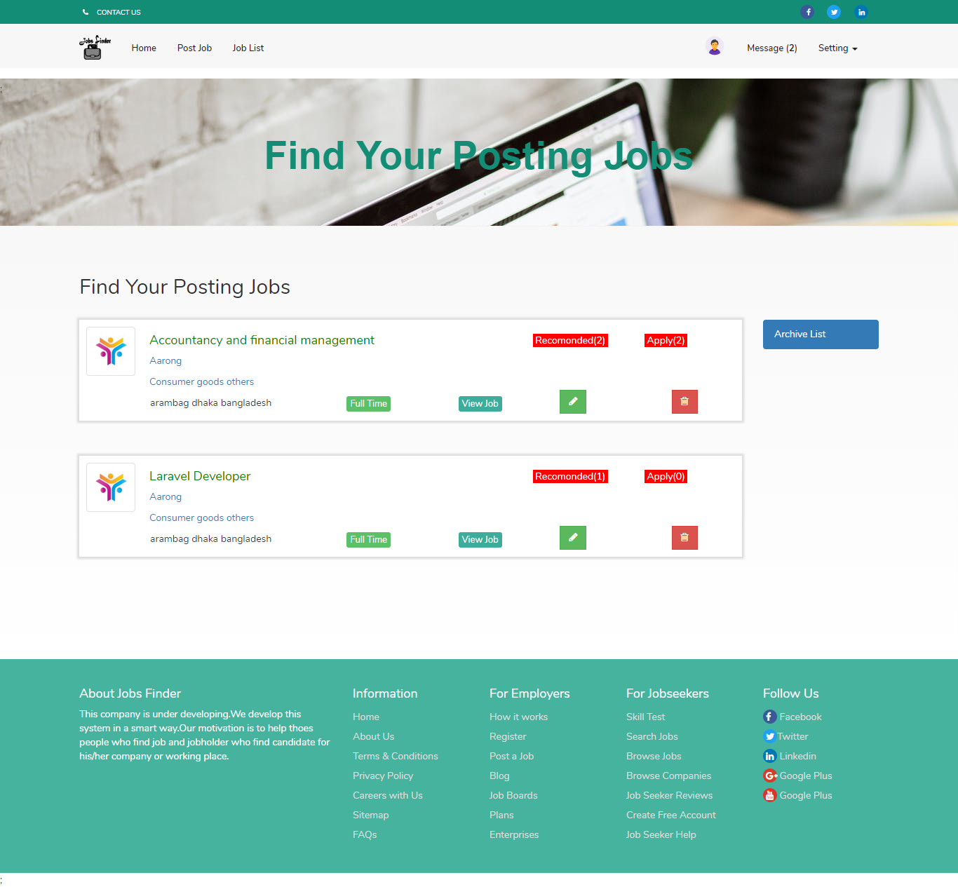

Figure 5.10 posting job

**Output:** Jobholder see their posting job.

### See candidate CV

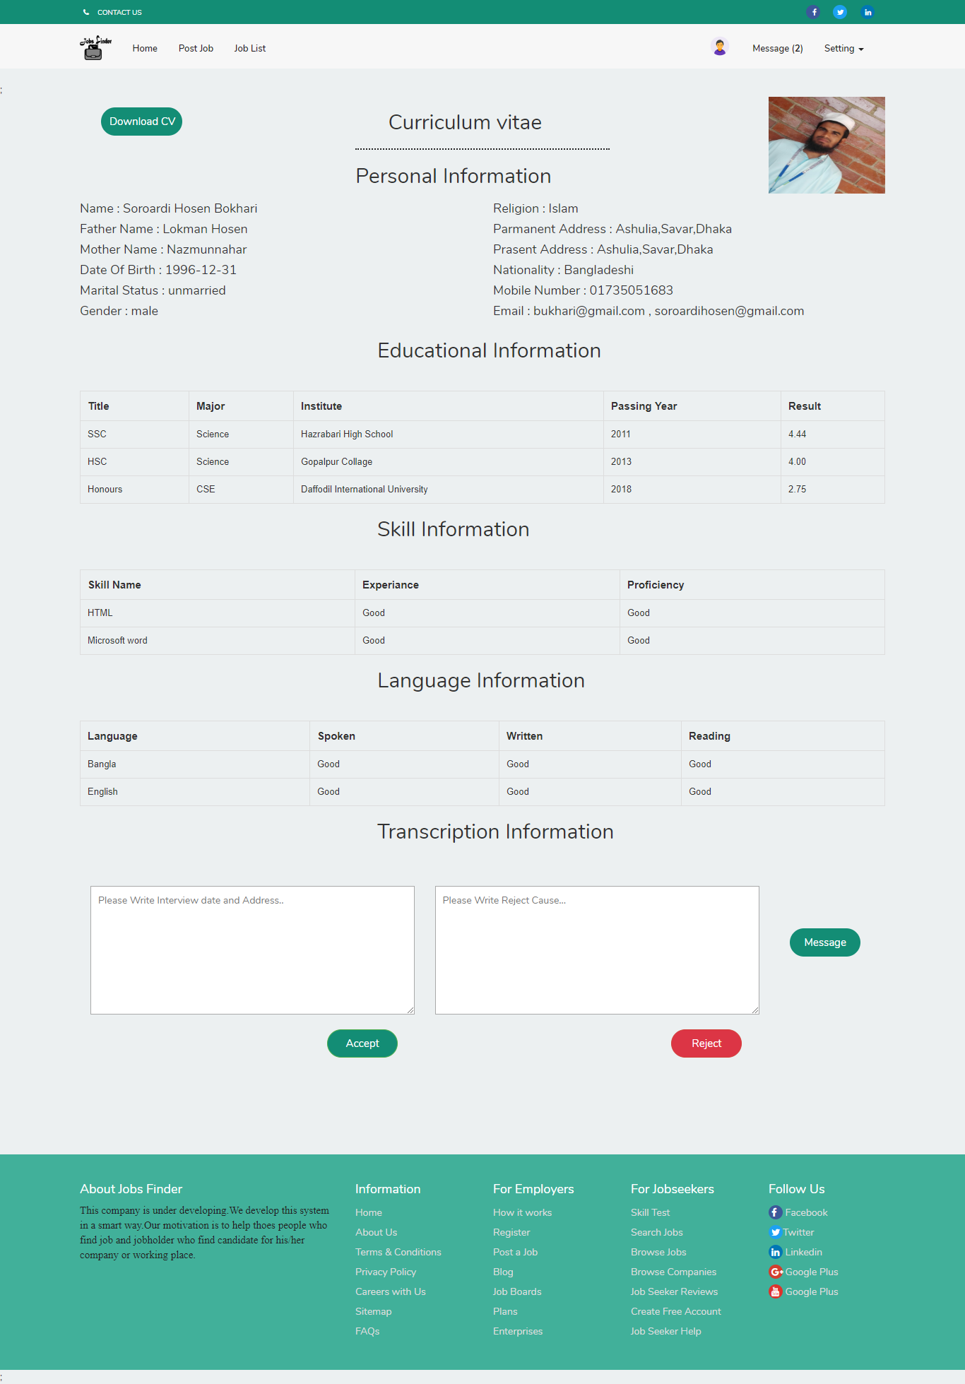

Figure 5.11 Candidate cv view

**Output:** Jobholder view candidate CV and can accept or reject it.

**5.2.11 Footer**



Figure 5.12 footer

**Output:** Here is see site map of project

# 5.3 Implementation of Interactions

Programming frameworks created as of late are ending up progressively intense, yet by and large they tend to desert the client to manage the multifaceted nature of the framework alone. Implementing the software design into the code and form design is the most significant part of the software [8]. This is the development phase of the application. In this phase codes are written and necessary requirements are assembled to build the software. There is a gigantic requirement for frameworks with individual, setting delicate help. The paper talks about the improvement of such an emotionally supportive network with exceptional spotlight on the UI. The augmentation of a current and complex program.

## 5.4 Implementation of Testing

**5.4.1 Main System testing**

Being the - landing page of the deployment entryway was tried for appropriate network to the database. Inappropriate advised linkage to the database was instantly corrected and confirmation was made to see that information were made enough recovered and exhibited without mistakes.

### 5.4.2 Database testing

Database testing was annoyed tested for network and capability. The test began with the plan organize, where activities were guaranteed that the right information representation was made.

**5.5 Test Results and Reports**

The performance of the system was very near the expected result .Throughout this structure, the advancement was done in modules. Every module was executed independently and tried. Extremely arrange involves troubleshooting, which was done and all blunder settled. The whole framework was coordinated by joining every module to work with the principle framework" At the finish of the combination, the whole framework was tried and confirmed Ok [6].

# Chapter 6: Conclusion and Future Scope

# 6.1 Discussion and Conclusion

Online interfaces are basic parts of the web that give a worldly connect to fundamental data assets. This venture work has possessed the capacity to actualize one for occupation enlistment works out. Finally, it very well may be reasoned that the Job Portal System was a genuine learning knowledge. The standards of task items were very much actualized all through the framework. The entire task experiences with loaded with energy and with brimming with happy minutes. The undertaking has been made according to as the given particular. The framework has been made as easy to use as conceivable by the utilization of HCI principals. Taking a shot at the Project was extremely a learning background and we have made some amazing progress in building our ideas of web designing. The "Employment Portal System" created by us is simply founded on the web stage. The general reason for this framework is to automate the entire procedure and along these lines avert interceding mistakes. We likewise endeavored to pursue the all-encompassing plan guideline with the goal that the interface of the framework is straightforward. Throughout this task, we have experienced numerous impediments which made us look into and through expanded our insight. Subsequent to applying every one of the information demonstrating, question displaying and process demonstrating methods now we are exceptionally well clear with every one of these ideas and essentials which will go help us later on more extensive regions of occupation looking encourage the fast and simple access to circumstances. This circumstance has provoked numerous to move to work entryways to search for the manners in which that have been broadly acknowledged and completely valuable in employment looking. In this sense, the activity entries expect more prominent significance and we could grow such a productive framework which is utilized by a great deal many occupation seekers and businesses.

# 6.2 Scope for Further Developments

This work had focused on improving the online job portals and tried to reduce some problems that existed in them by developing a knowledge system that also acts as a job portal. Thus, this portal can be more beneficial with further enhancements the services and features. A few areas of the future works are outlined below:

* In future we want to make an android version to reaches more people.
* A job seeker has the option to set the privacy level to control how much information is visible to employers through resume searches. The user has got to attack Privacy Level whereas posting or making CV and so check from an inventory of private/public/confidential resumes choice.
* We also create interview in our system .Future Expert recommendation for job-seekers in the way to prepare, manage - and succeed - in your next digital camera, Skype, Google haunt, or Face time interview.
* Need to improve technical support and skill content which help the job seeker

To increase his skill and job holder requirement.

* Job notification alert direct phone
* To Make it global

**REFERENCES**

|  |  |
| --- | --- |
| [1] | A. Samuel, "DESIGN AND IMPLEMENTATION OF WEB BASED RECRUITMENT PORTAL (A case study of Nigeria Civil Service Commission Enugu) BY NWAMAGHINNA BLESSING," 2016 10 12. [Online]. Available: http://www.academia.edu/14695018/DESIGN_AND_IMPLEMENTATION_OF_WEB_BASED_RECRUITMENT_PORTAL_A_case_study_of_Nigeria_Civil_Service_Commission_Enugu_BY_NWAMAGHINNA_BLESSING. [Accessed 20 august 2018]. |
| [2] | S. Kher, "Designing a Database for an Online Job Portal," 15 November 2016. [Online]. Available: http://www.vertabelo.com/blog/technical-articles/designing-a-database-for-an-online-job-portal. [Accessed 12 june 2018]. |
| [3] | A. I. Muqsit, "BDjobs," 1 july 2000. [Online]. Available: http://www.bdjobs.com/. [Accessed 1 june 2018]. |
| [4] | indeed, "indeed.com," 17 6 2016. [Online]. Available: https://www.indeed.com/about?from=careeradvice-US. [Accessed 7 september 2018]. |
| [5] | W. &. WHATWG, "Hypertext Markup Language (HTML)," 14 december 2017. [Online]. Available: https://en.wikipedia.org/wiki/HTML. [Accessed 4 september 2018]. |
| [6] | M. A. S. J. Saluja, "JOB PORTAL SYSTEM," 6 February 2013. [Online]. Available: https://www.slideshare.net/masterpiyush/documentation-18684935. [Accessed 28 august 2018]. |
| [7] | U. o. A. A. Rawalpindi, "Online job portal web based application, Projects for Computer Science. University of Arid Agriculture Rawalpindi," 4 june 2017. [Online]. Available: https://www.docsity.com/en/online-job-portal-web-based-application/1982645/. [Accessed 29 july 2018]. |
| [8] | N. Researchers, "DESIGN AND IMPLEMENTATION OF AN ONLINE JOB PORTAL," 6 january 2011. [Online]. Available: https://nairaproject.com/projects/4131.html. [Accessed 17 july 2018]. |
| [9] | bdjobstoday, "IT Officer," bdjobstoday, 7 6 2015. [Online]. Available: http://www.bdjobstoday.com/jobs_today.php. [Accessed 1 septembet 2018]. |
| [10] | C. C. Adam D'Angelo, "Which job is best in information technology?," Quora, 21 june 2010. [Online]. Available: https://www.quora.com/Which-job-is-best-in-information-technology. [Accessed 16 august 2018]. |
| [11] | S. Paulo, "scielo," EDUCAÇÃO, 3 2 2015. [Online]. Available: http://www.scielo.br/scielo.php?script=sci_arttext&pid=S0100-40422015001001351. [Accessed 7 8 2018]. |